# Using different js script files

Using separate js scripts helps in the caching for example, if you have not made any changes to the script tag and you again open the same website then the website will load faster because that script file will be in the cache

1. Separation of concerns
2. Browser caching

# JavaScript console objects Methods



Console.error // is in red color

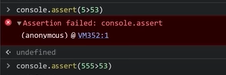

Console.assert //Is used to assert a condition

//if the condition is true it won’t show anything

//only shows error if the condition is false,otherwise won’t show anything

Console.clear() is used to clear the console

Console.table // first create an object

//very effective for viewing tables

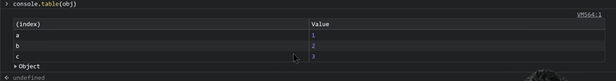

Console.warn



Console.info and console.log are almost same

Console.time(“label”);

Console.timeEnd(“SEM LABEL”)

CODE EXAMPLE OF time and timeEnd

let array = [];

let x;

console.time("a")

for (let i = 0; i < 10; i++) {

x = prompt("ENTER THE " + i + " VALUE");

array.push(x);

}

console.timeEnd("a");)

REMEMBER KE PROMPT BY DEFAULT STRING INPUT KRTA HAI

CHANGE THE STRING INTO INT BY USING THIS FUNCITON

Num=Number.parseInt(Num)

Interaction with the user

Confirm

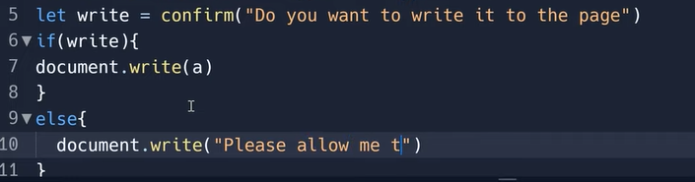

DOM , BOM AND windowObject



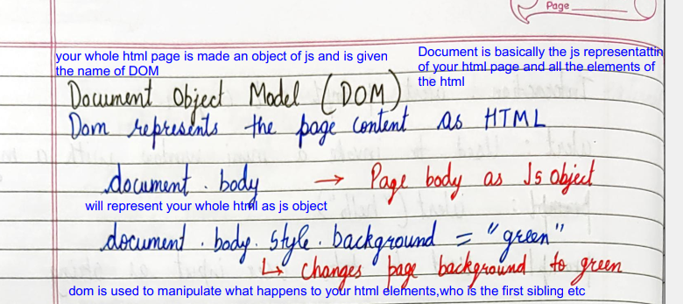

document.body.style.backgroundColor=x;

dovument.body is used to acces the body of the html page and then you can further manipulate it.